**ASSIGNMENT-10**

**(15th JUNE 2022)**

NAME –Shaik Mohammed Raihan ROLLNO – DXC262AB12036

BATCH – DXC-262-ANALYTICS-B12-AZURE COMPANY – DXC TECHNOLOGY

EMPLOYEE DOMAIN – AZURE ANALYTICS TRAINER NAME – MR. AJAY KUMAR

DATE OF SUBMISSION – 15th JUNE 2022 NO. OF QUESTIONS: 6

**Case 1**. Using archive1.zip file - please ingest data into Databricks DBFS path & query the data, redesign columns accordingly using Dataframe commands - display with notebooks accordingly.

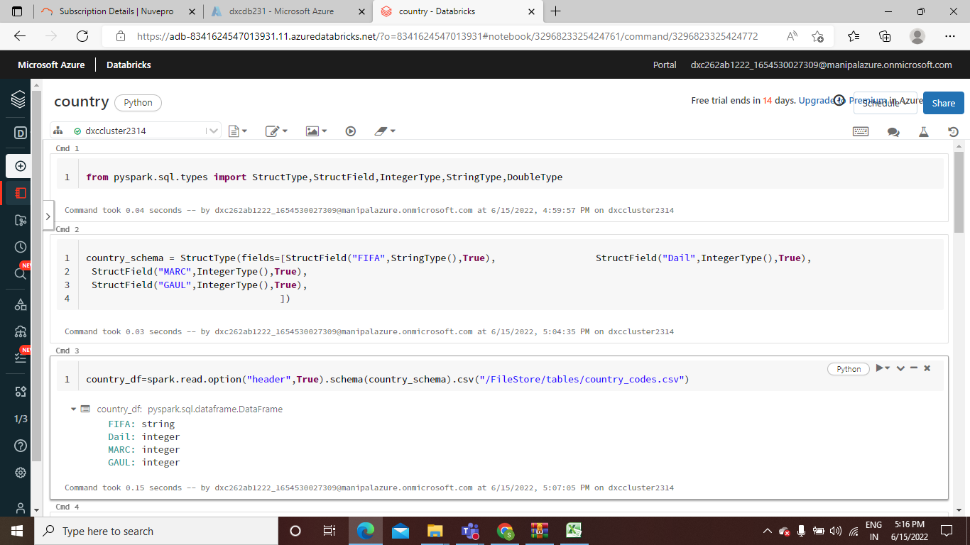

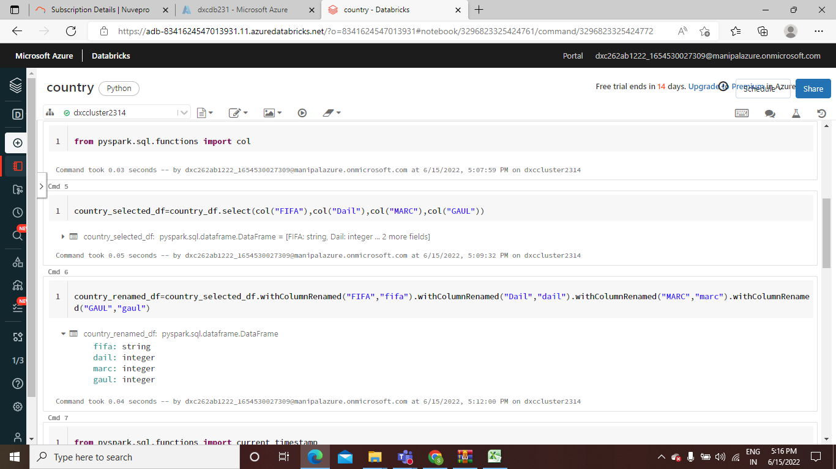

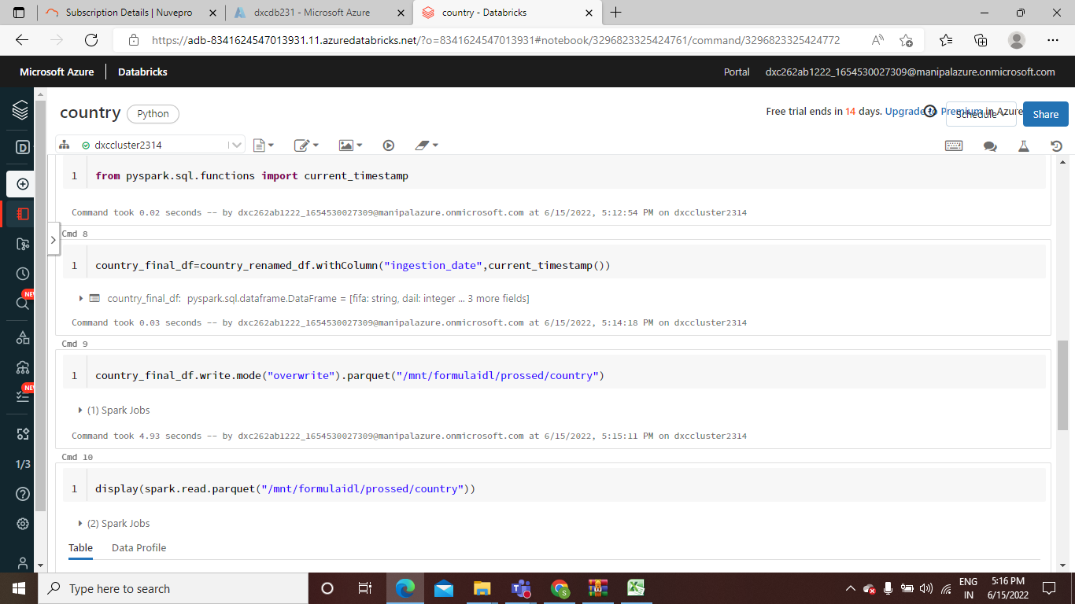

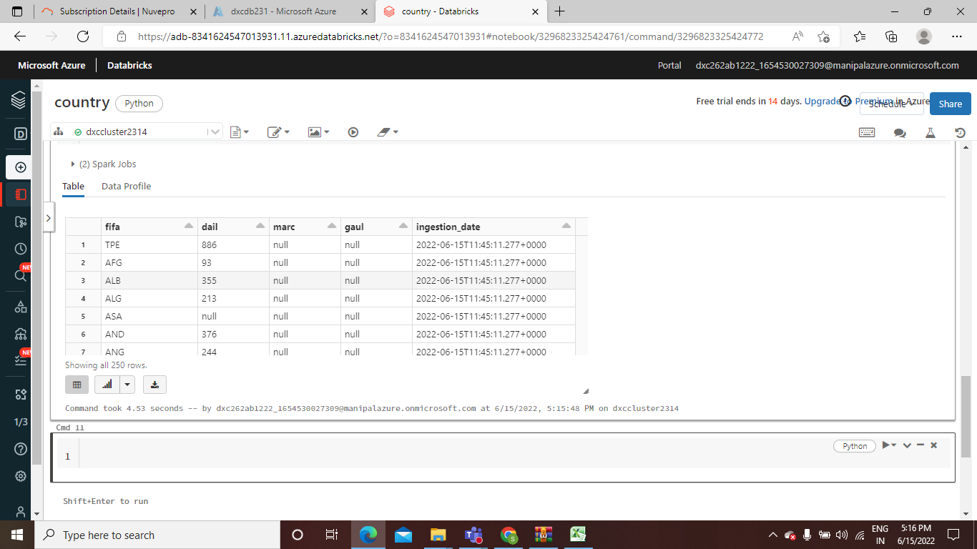

**Case 2.** Using archive2.zip file - please ingest data into Databricks DBFS path & query the data, redesign columns accordingly using Dataframe commands - display with notebooks accordingly.

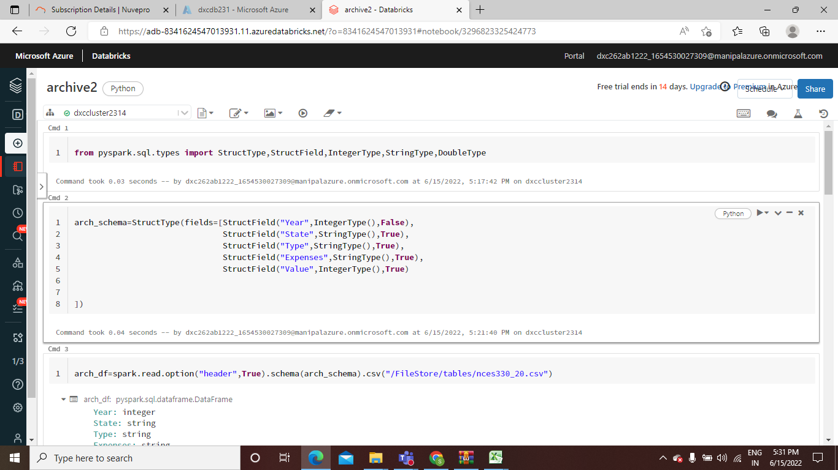

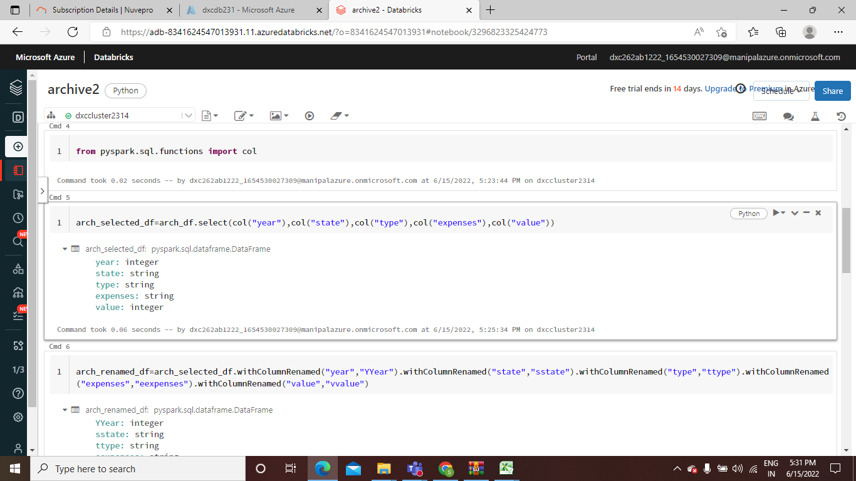

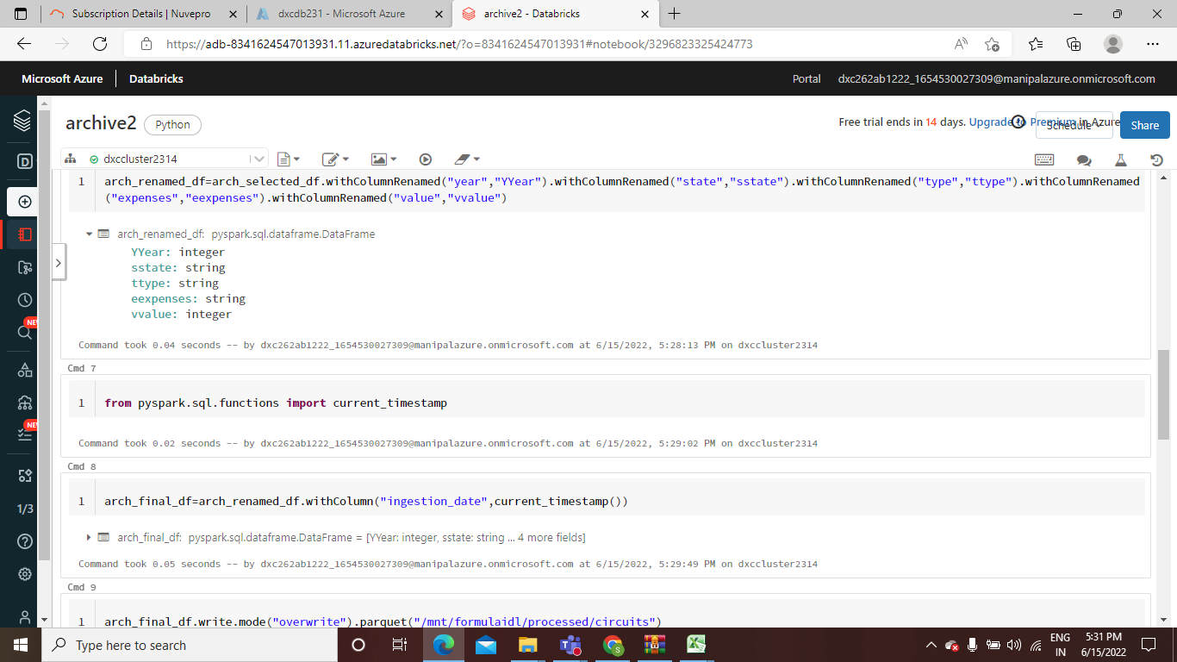

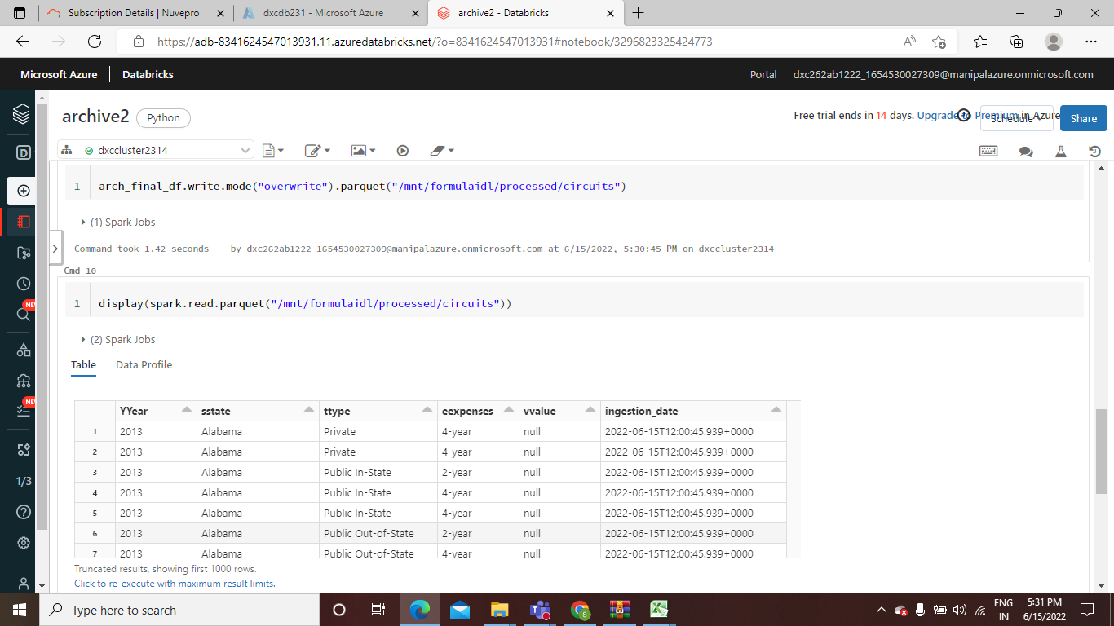

**Case 3.** Using archive3.zip file - please ingest data into Databricks DBFS path & query the data, redesign columns accordingly using Dataframe commands - display with notebooks accordingly.

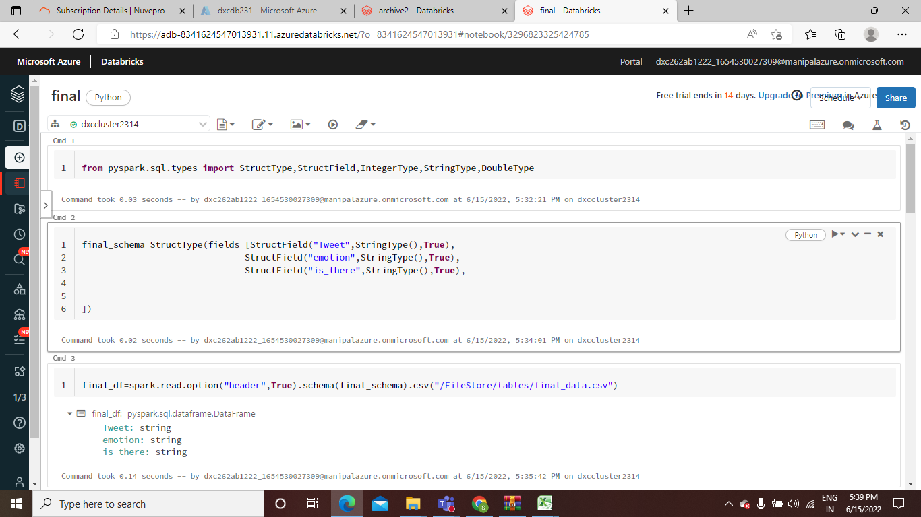

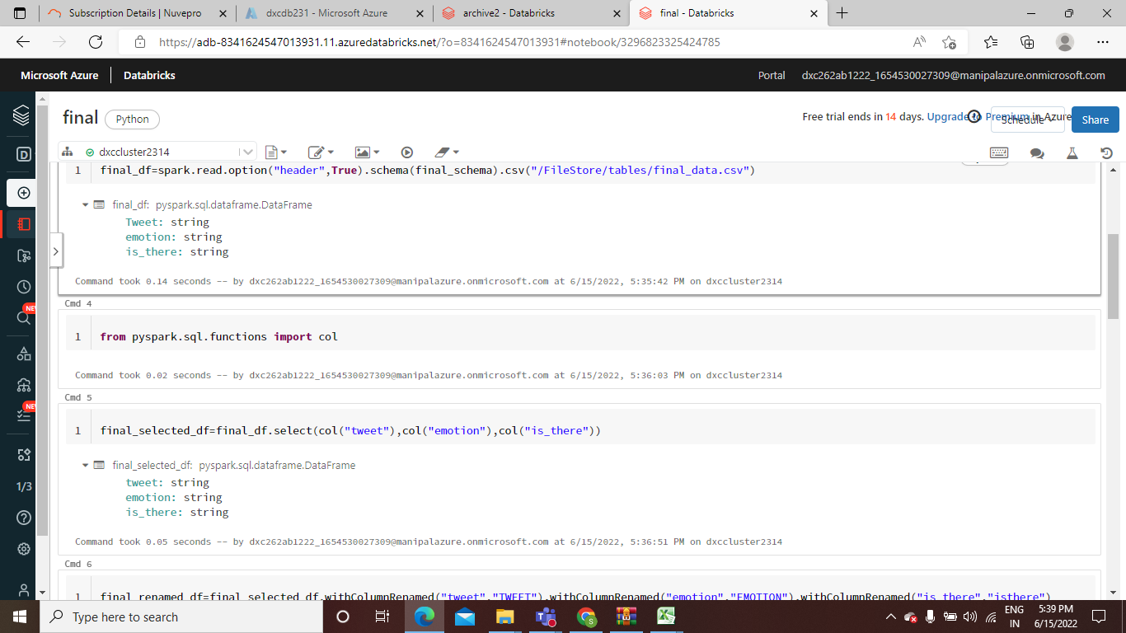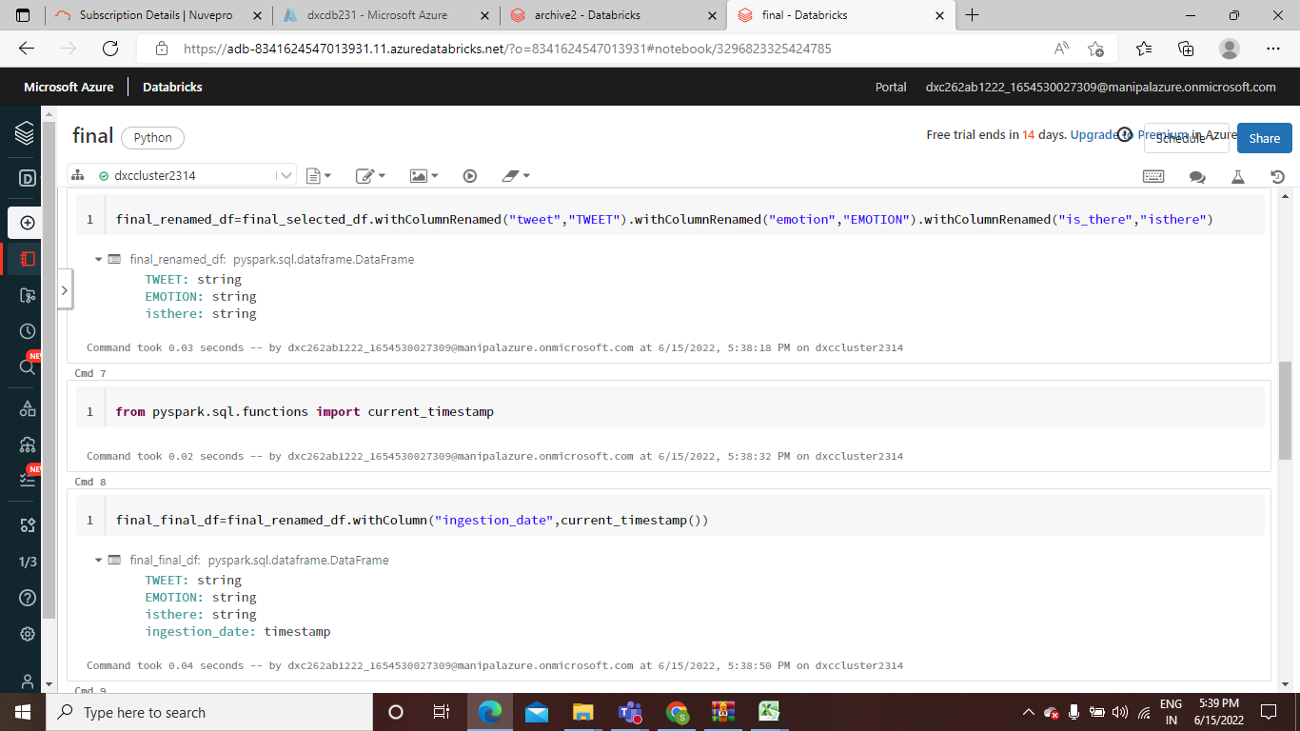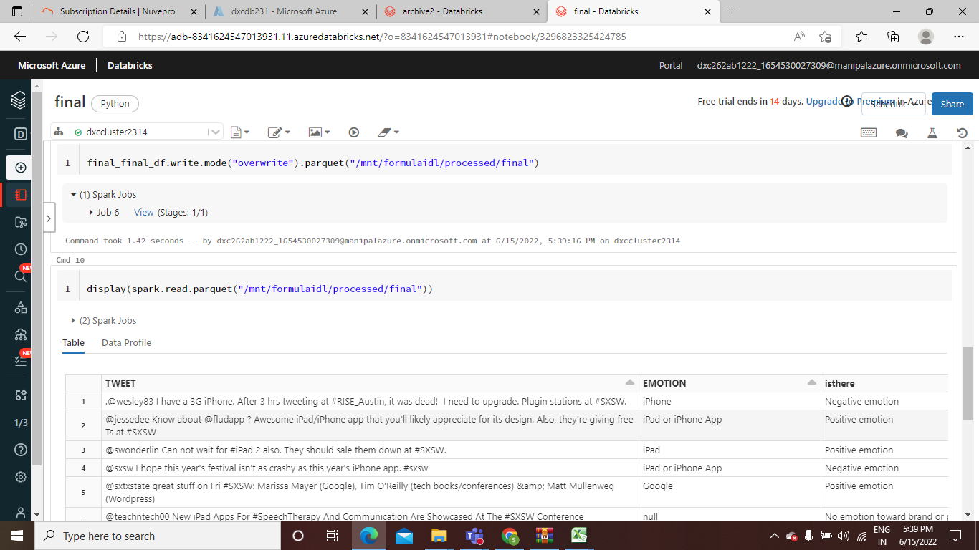

**Case 4.** Using archive4.zip file - please ingest data into Databricks DBFS path & query the data, redesign columns accordingly using Dataframe commands - display with notebooks accordingly.

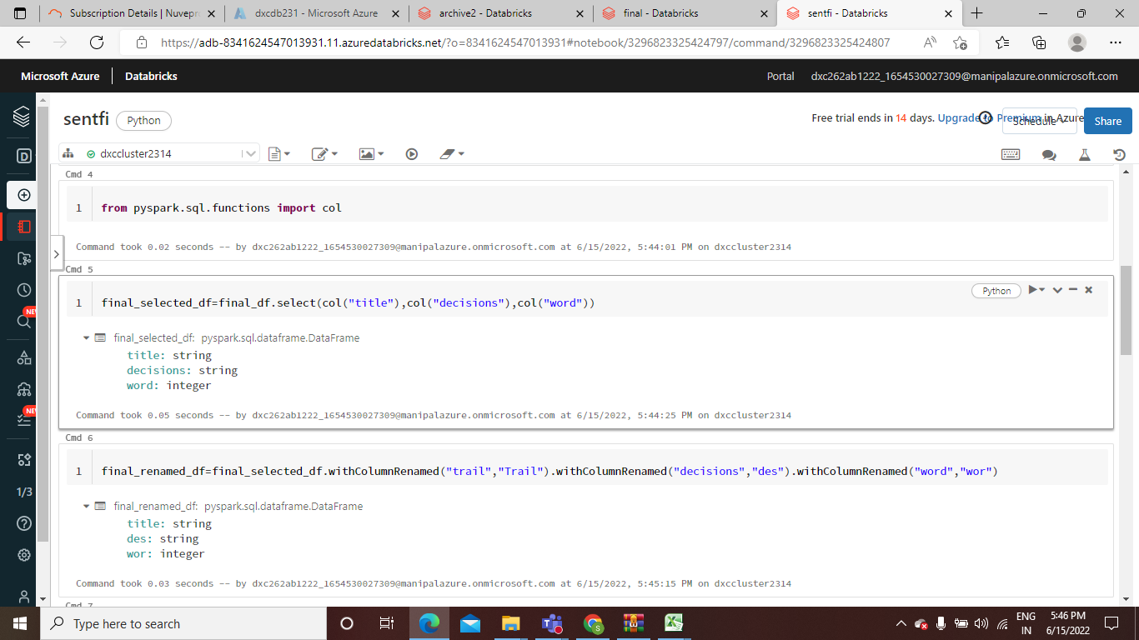

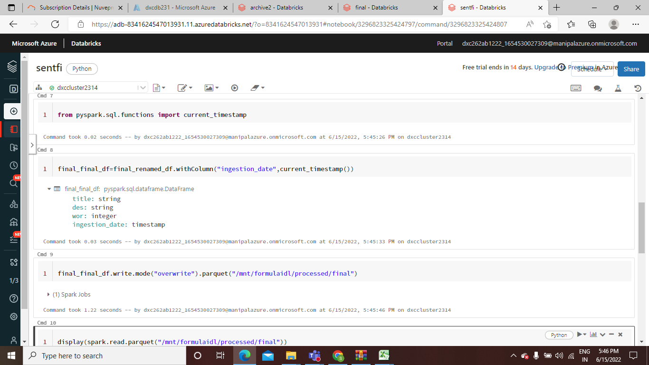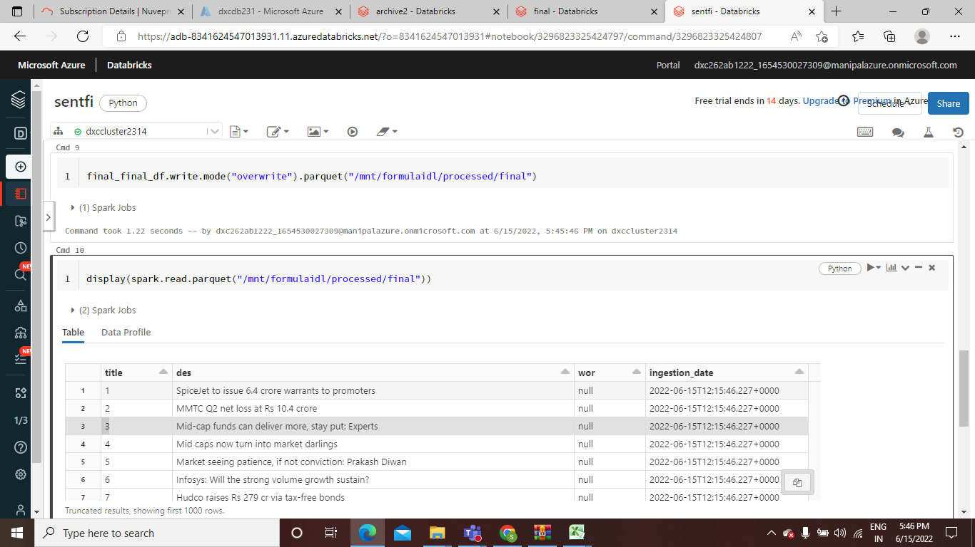

Case 5. Using archive5.zip file - please ingest data into Databricks DBFS path & query the data, redesign columns accordingly using Dataframe commands - display with notebooks accordingly.

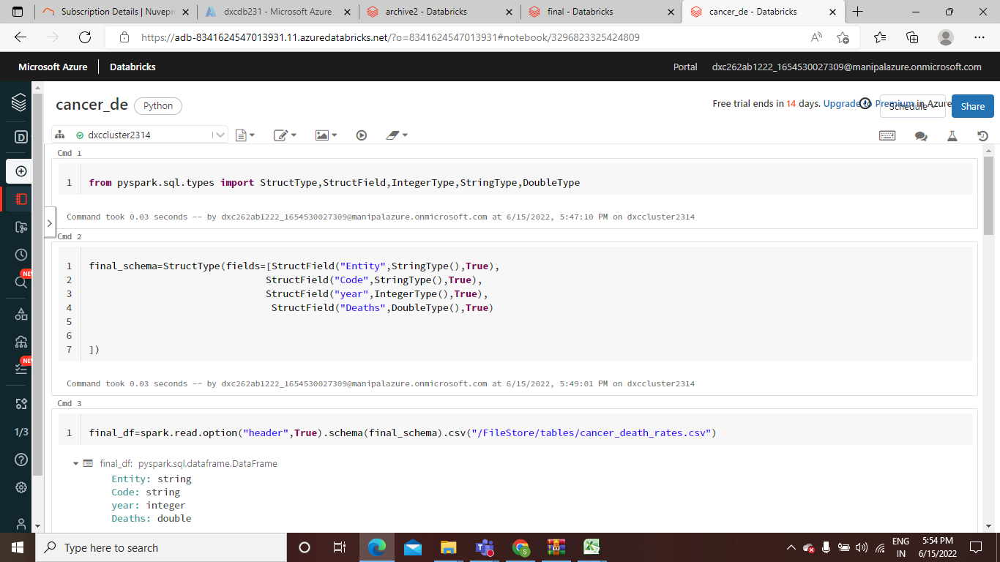

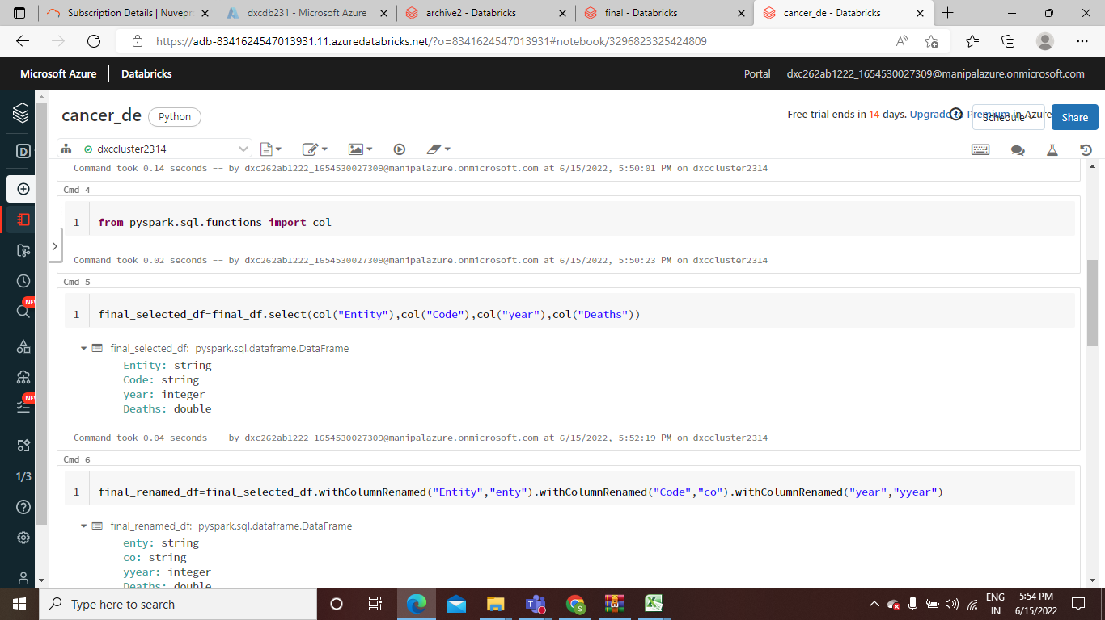

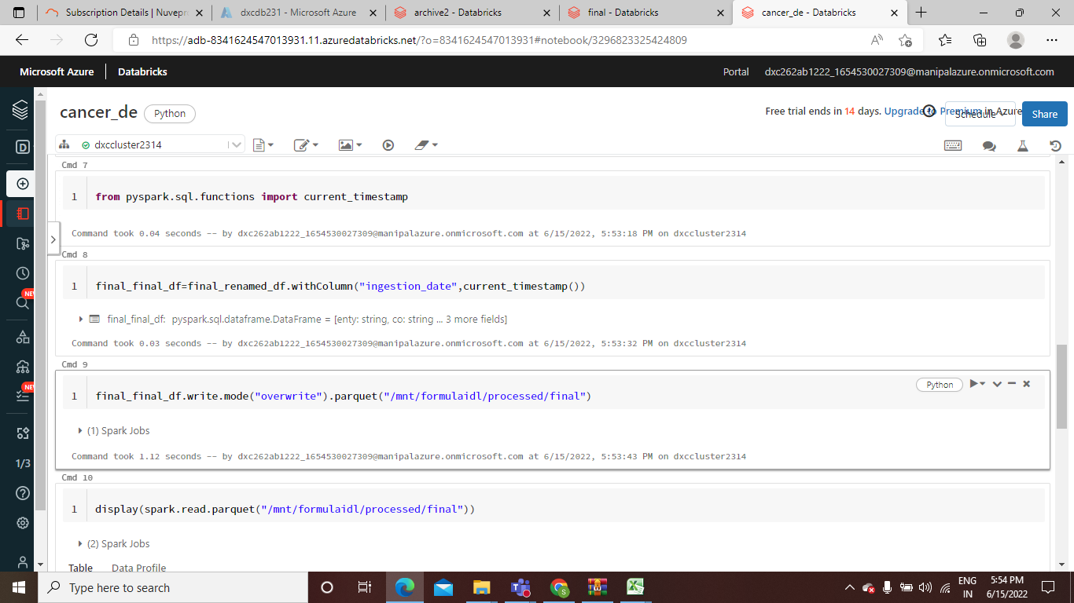

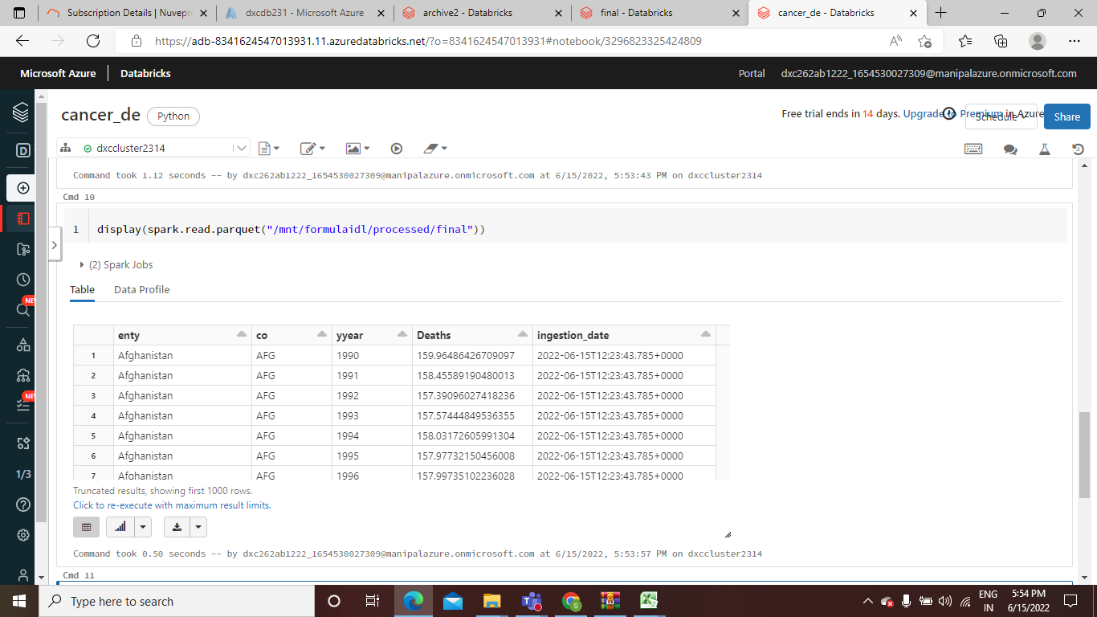

Case 6. Using archive6.zip file - please ingest data into Databricks DBFS path & query the data, redesign columns accordingly using Dataframe commands - display with notebooks accordingly.

